MGMS – Create Site Admin

Functional Specification Document

Ver. 1.4

Version History
Version # | Date | Description
1.0 | 23-Oct -2010 | First Draft
1.1 | 18-Nov-2010 | Added password rules

Table of Contents

Version History 2
1 Introduction 4
1.1 Purpose 4
1.2 Scope 4
1.3 Assumptions 4
1.4 Constraints 4
2 Create Site Admin 4
3 Business Rules 5
4 Status Messages 5

Introduction

Purpose

This document provides the requirements and functional specifications for the Multisite Grant Management System project.

This is not a project plan or a design document. It is a guide for system architecture and development, not for phasing, timelines or deliverables.

Finally, this is a ‘living document’ and the specification will change, continuously, as the project proceeds. More details will be added and the existing information edited as the requirements, scenarios and use cases evolve in the course of the project.

Scope

Assumptions

Constraints

Create Site Admin

Clicking on “Register” link in the Log-in Home page, will take the user to the “Create Site Admin” page, and it is the first step towards registering the institution.

This site admin is the key representative of the institution and uses the GMS on behalf of the institution.

Screen & Control Description

Figure 1: Create Site Admin
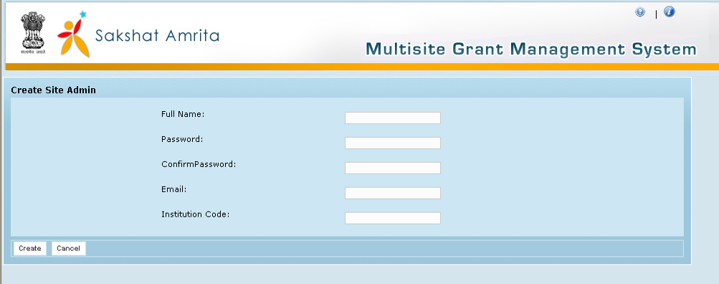

Field /Label | Input-Control | Data Type | Details
Create Site Admin
Full Name: | Textbox | String | Required
Password: | Textbox | String | Required
Confirm Password: | Textbox | String | Required (Just for confirmation); Validation required to check that both entries are same. If not, alert user with pop message
Email: | Textbox | String | Required
Institution Code: | Textbox | String | Required
Create | Button |  | On clicking, System will send activation link along with login ID and Password to the email address provided
Cancel | Button |  | Removes the details filled into the fields above

Registration confirmation Page

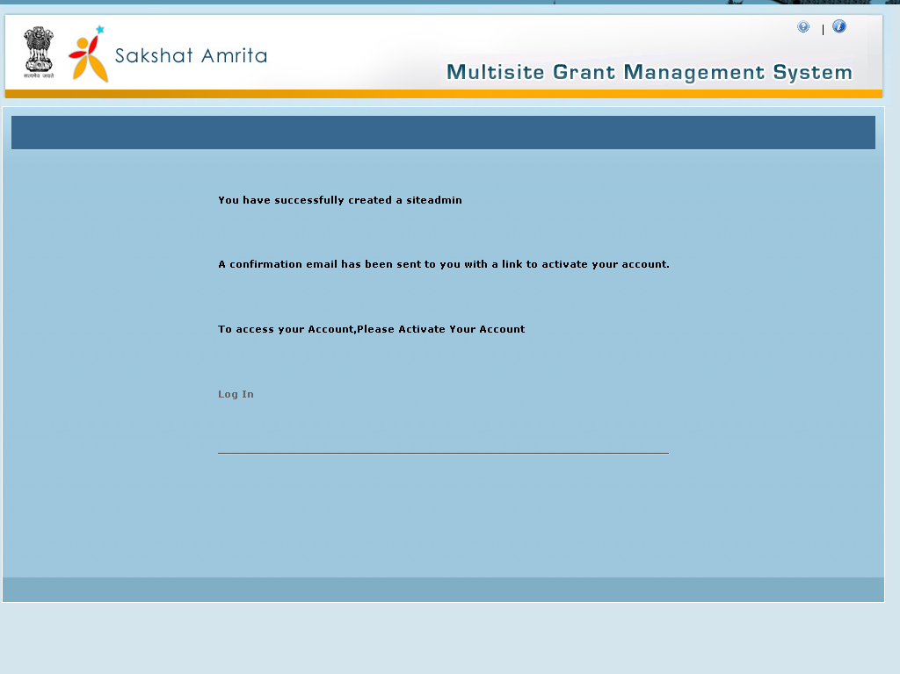

Confirmation E-Mail format:

From: no-reply@yourdomain.com

To: <email addr. of the site-admin>

Sent: <date-time format for e.g., Tuesday, January 11, 2011 5:35:21 PM >

Subject: Welcome to Grant Management System (GMS) under NME ICT, MHRD

Dear <site admin name>,

Thank you for registering for the Grant Management System (GMS). A GMS user account has been created with following details .
LoginName : <email addr. of the site-admin>
Password : <password entered/confirmed by the site admin>

To activate your account, click on the following link : http://192.168.18.95:8080/gms/user/userActivation/93

GMS is the first open source, enterprise-wide grants management system to be developed under the NME ICT initiative of MHRD. The application is web-based and follows a cloud deployment model and serves to connect all those involved in and responsible for sponsored research administration. Please visit our website at http://sakshat.amrita.ac.in/erp/ where you will find an overview of everything you need to know about the National Mission project on ERP under NME ICT. If you have any questions you may write to us at amritaerp@gmail.com

Welcome to the NME ICT Community!

Regards,
Your ERP Team at Amrita

e-mail: amritaerp@gmail.com
website: http://sakshat.amrita.ac.in/erp/
Activation confirmation page

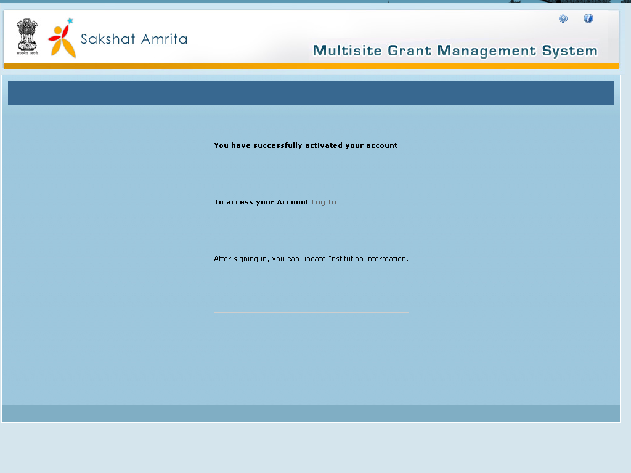
Click on Login

Click the login link to go to Log in

Business Rules

Status Messages

Sl No | Status Message
1 | Created Successfully
2 | Updated Successfully
3 | Deleted Successfully
4 | The Requested Record Not Found
5 | The Record can't be deleted, Already in use
6 | The Record Already Exists
7 | Please Enter a valid email address
8 | You can not delete yourself, please login as another admin and try again
9 | Please Enter New Password
10 | Please Enter Full Name
11 | Please enter Password
12 | Please enter confirm Password
13 | Please enter Institution Code
14 | The confirm password entered does not match the password

